This media release is embargoed until 1 October 2024, 10 a.m. CEST

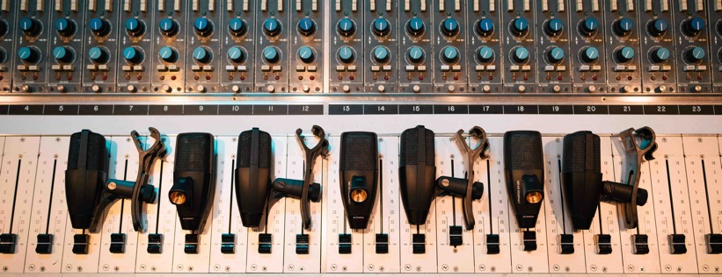”Anything. That’s the mic for that.”
Sennheiser launches the MD 421 Kompakt – an aptly named, compact version of legendary allrounders, the MD 421 and MD 421-II

Wedemark, October 2024 – They say that if you’ve heard music, you are most likely to have heard the MD 421, a Sennheiser microphone featured in countless award-winning performances and productions over the past six decades. Now Sennheiser launches the MD 421 Kompakt, an incredibly versatile microphone that delivers the same legendary performance, but in a truly multipurpose package — including a completely redesigned mounting clip. The MD 421 Kompakt features a cardioid pick-up pattern and remarkable dynamic range, delivering crystal-clear sound reproduction in live sound and recording applications.

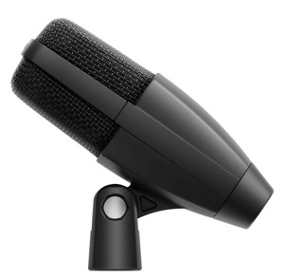 | 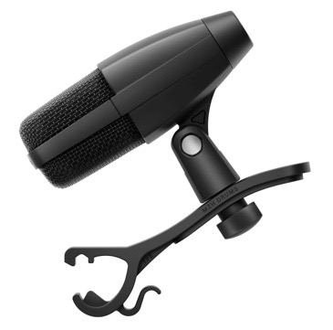
The MD 421 Kompakt (left) and the MD 421 Kompakt for Drums, which comes with additional MZH drum clamp

“The MD 421 is an incredibly versatile microphone. Since its inception in 1960, it excelled as a studio and a vocal microphone, but was also used a lot in broadcasting, where it appeared with many celebrities of the time. Today, its successor, the MD 421-II, which launched in 1998, is an allrounder for multipurpose miking and well known to be used on drums, guitar cabs and horns,” says Bertram Zimmermann, Manager Live Sound & Studio. “It works on anything, capturing the sound source with precision, detail, and rich sound.”

“With the MD 421 Kompakt, we’re offering the same legendary sound and ability to handle high sound pressure levels, but with an incredibly compact form factor,” adds Jimmy Landry, Category Marketing Manager MI.

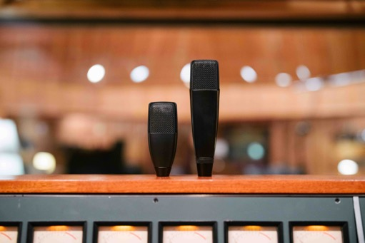 | The large-diaphragm MD 421 Kompakt offers the same legendary sound as the MD 421-II (right)

Compact design, same great sound
To give the MD 421 microphone its compact dimensions all while retaining the large-diaphragm capsule and the pristine sound of the much bigger MD 421-II, the bass roll-off switch was eliminated. “While this feature made total sense when the MD 421 was designed, and was carried over to the MD 421-II, this functionality has long since been taken over by mixing desks and DAWs,” says Zimmermann. “Omitting the switch allowed us to create a relatively small microphone body, making the Kompakt an ideal tom mic, but also a versatile tool for any recording or live application.”

Sound-wise, the MD 421 Kompakt delivers the same detailed and authentic reproduction of the sound source that the MD 421 and MD 421-II have become famous for. The microphone’s frequency response of 30 Hz to 17 kHz faithfully reproduces both high and low frequencies, with a bass tube ensuring an accurate and extended low-end response. The sound is rich and full-bodied, and incredibly clear and detailed at the same time.

The MD 421 Kompakt also provides effective feedback rejection, and is able to handle exceptionally high sound pressure levels even in demanding environments.

New clip
The clip of the MD 421 Kompakt has been entirely redesigned, and is now part of the microphone housing for easy, worry-free mounting. “The clip is the one thing that users have always criticised,” remarks Landry. “The new clip is an integral part of the mic, and the optional drum clamp securely screws into this clip, ensuring fail-safe mounting on drums.”

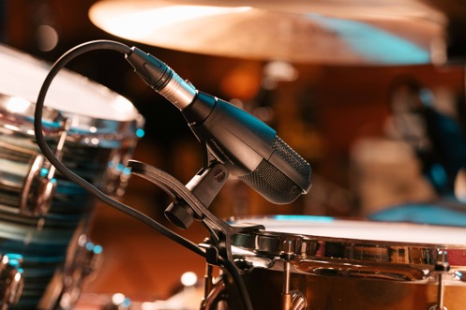 | The drum version of the MD 421 Kompakt comes with a drum clamp that securely screws into the redesigned mic clip – a fail-safe mechanism for drum miking

Rugged all around
The MD 421 Kompakt is designed to withstand the rigours of touring and heavy studio use. It features a rugged frame with a stainless-steel basket, and a gold-plated XLR-3 connector. A protective inner chassis enclosure reduces the exposure to dust and humidity.

The MD 421 Kompakt provides the same great cab sound as the bigger MD 421-II | 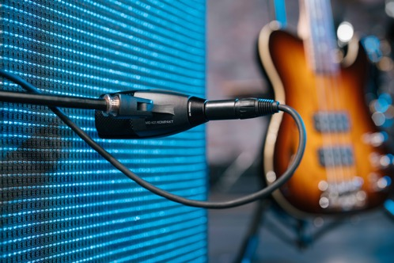

Availability and pricing
The MD 421 Kompakt is available now for EUR 279 (MSRP), the version for drums comes complete with an MZH drum clamp and retails at EUR 299 (MSRP). The MZH drum clamp included with the drum version is also available separately for EUR 19 (MSRP). The MD 421-II will remain in the portfolio alongside the MD 421 Kompakt.

With its pristine, detailed sound, compact size and excellent feedback rejection and handling of high sound pressure levels, the MD 421 Kompakt is a versatile multi-purpose microphone | 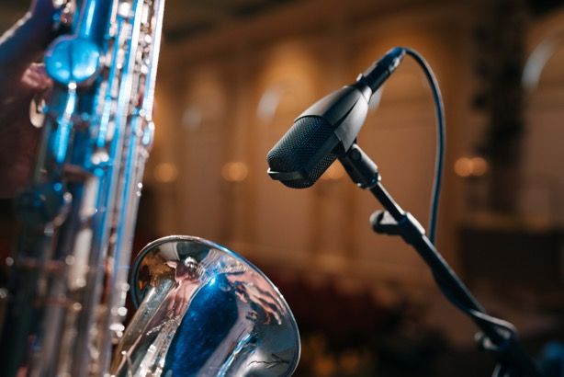

(Ends)

Additional information for the editor

The high-resolution images accompanying this media release and a selection of additional application photos can be downloaded here. All application photos are also available in a higher resolution – simply reach out to your local PR manager.

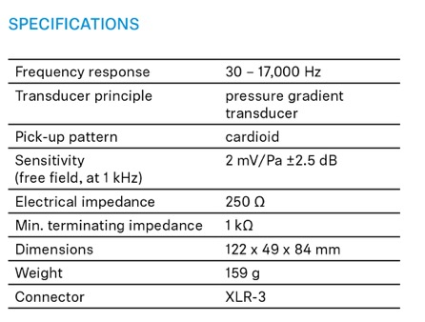
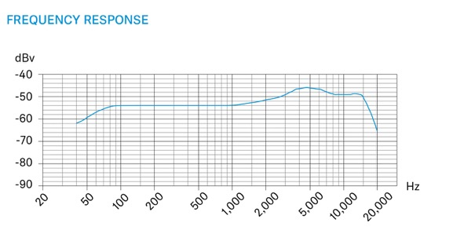

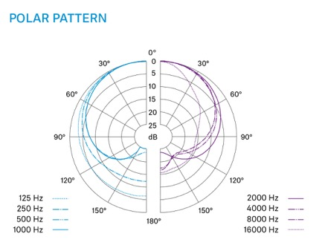

About the Sennheiser brand
We live and breathe audio. We are driven by the passion to create audio solutions that make a difference. Building the future of audio and bringing remarkable sound experiences to our customers – this is what the Sennheiser brand has represented for more than 75 years. While professional audio solutions such as microphones, meeting solutions, streaming technologies and monitoring systems are part of the business of Sennheiser electronic SE & Co. KG, the business with consumer devices such as headphones, soundbars and speech-enhanced hearables is operated by Sonova Holding AG under the license of Sennheiser.

www.sennheiser.com
www.sennheiser-hearing.com

Global Pro Audio Press Contact
Stephanie Schmidt
stephanie.schmidt@sennheiser.com
+49 (5130) 600 – 1275

